

**Purpose:** This job aid shows how to switch the primary job for a team member who has multiple jobs at Northeastern.

**Steps to switch primary job:**

1. In the **Workday search bar**, start typing in the words, “switch primary job”.

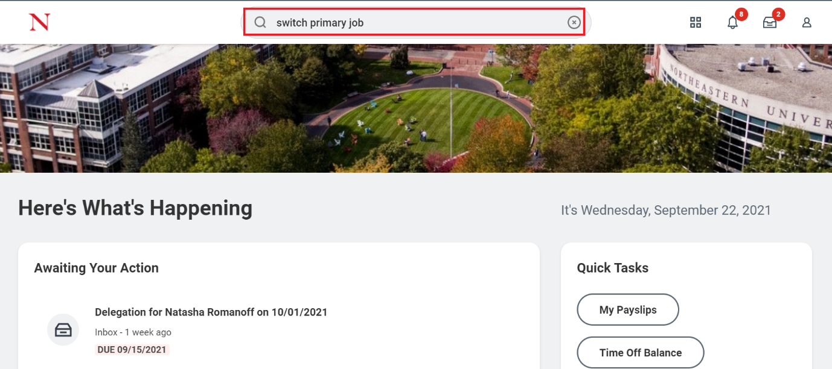

1. **Click** the **Switch Primary Job** task from the search results.

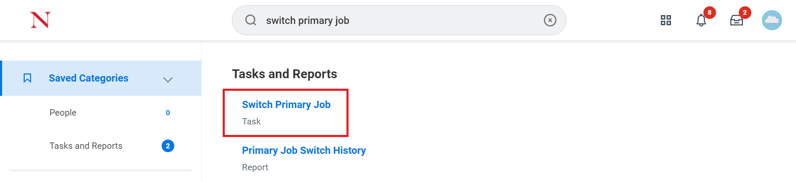

1. In the **Worker** field, search the name of the team member and click **OK** to continue.

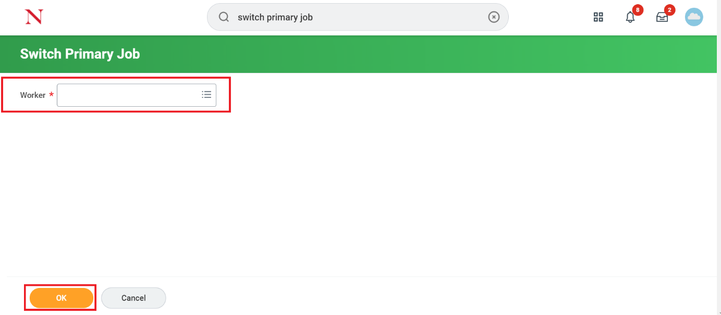

1. Click the pen icon  to edit the entries.
2. In the **Reason** field, search for the reason that best fits the purpose of switching the primary job and enter the **Effective Date**.

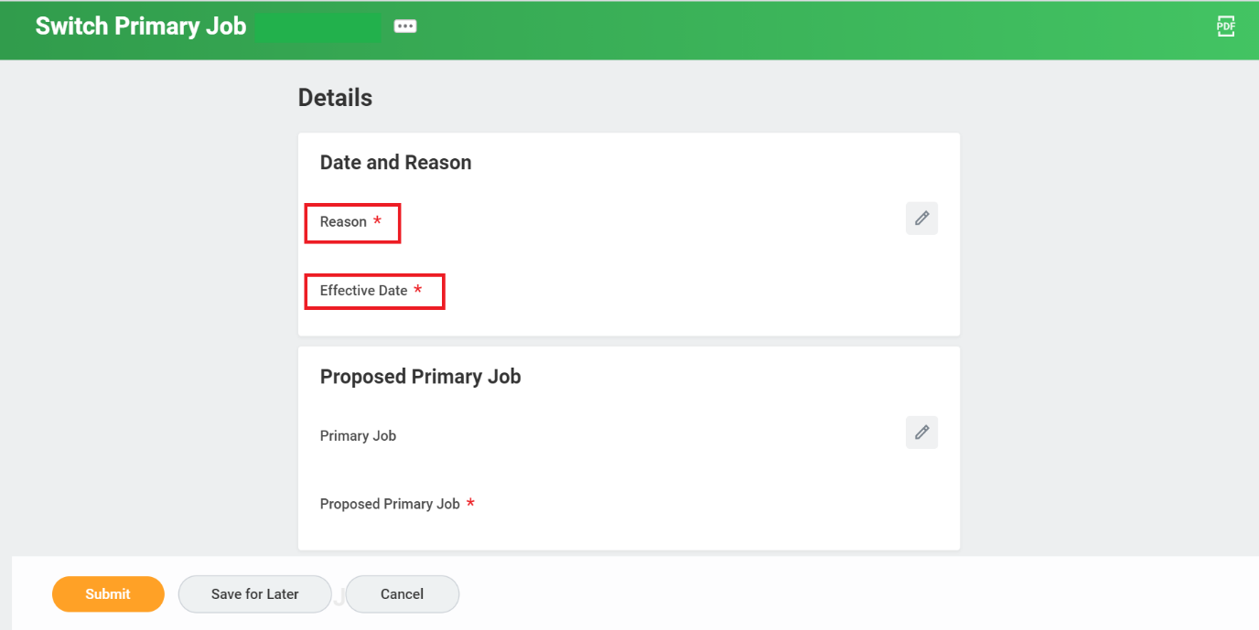

1. In the **Proposed Primary** **Job** field, choose the position that will become primary.

1. Review your entries and click **Submit** to finalize the request.

**Result:**

You have submitted the switch primary job request which will now be routed for approval, as needed.