

**Purpose:** Onboarding is a key piece in the student employee life cycle. This job aid describes the steps to set up onboarding for a new student employee in Workday. This business process kicks off after the employee has been hired officially.

**Steps to set up onboarding for a new hire:**

1. Click the **Tray** icon on the top right corner of your Workday Homepage to navigate to your Inbox.
2. The **Inbox** screen appears.
3. Click the **Onboarding Setup for Hire** message.

1. The **Onboarding Setup** screen appears. The Message to the new hire and the **Notification Message** to the point of contact(s) are auto populated. It is encouraged that you personalize these items to your team and new team member.
2. Enter the name(s) of other employee(s) that the student employee should meet in the **Select People** field. Ensure that the **Notify** checkbox is selected.

**Note**: the message and selected people will be visible to the new hire via the Onboarding Dashboard.

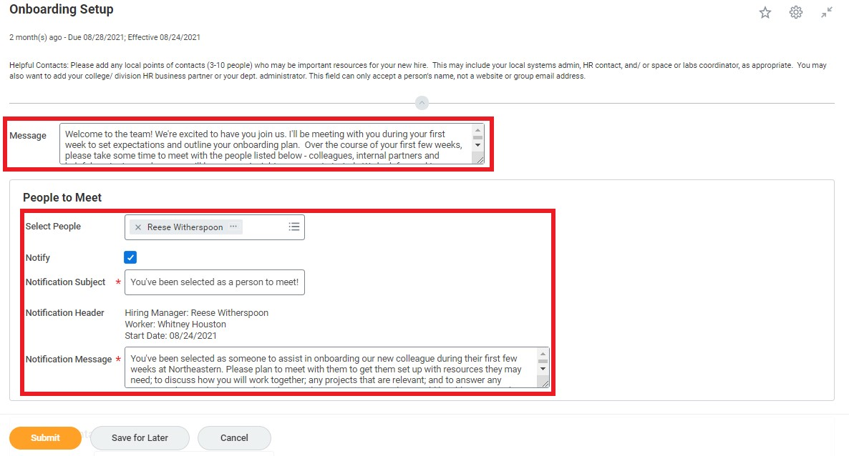

1. Enter the **Helpful Contact** names if any – this would be a great place to include contacts within the Student Employment Office for additional support. Click **Submit** to confirm.

1. A pop-up message appears, “**Success! Event Submitted**”.

**Result:**

You have completed the steps to set up onboarding for a new student employee in Workday.