

**Purpose:** This job aid shows employees how to set up the Workday application on Apple mobile devices.

**Steps to set up Workday on mobile on IOS/Apple device:**

1. On your mobile device, navigate to the **App Store**.
2. Enter **Workday** in the **Search** field and select **Workday** from the results. The click **Get** and **Install**.

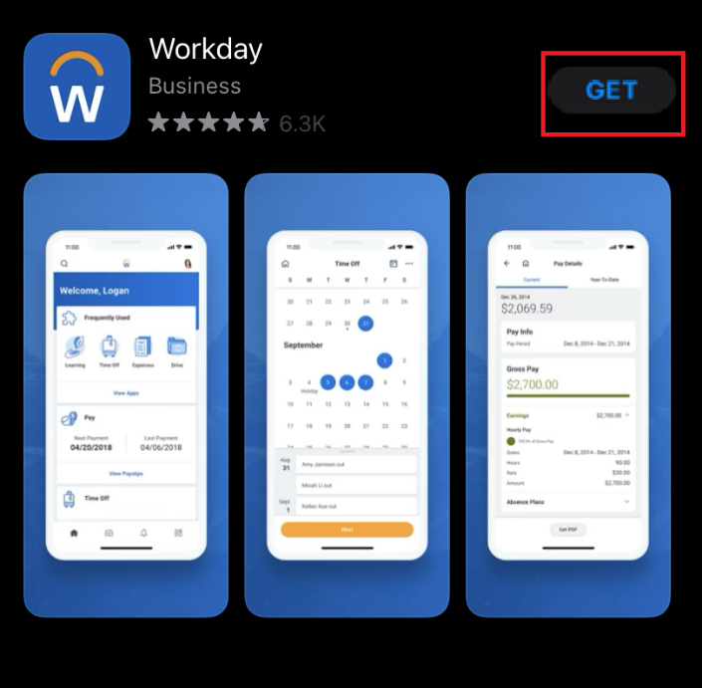

1. Click **Open** once the app is downloaded.

|  |  |
| --- | --- |
| 4. Click **Log In.**   | 5. Enter the **Organization ID** – northeastern— to identify the Northeastern University tenant.  **Note**: The Northeastern tenant will not be available to access on mobile devices until launch. |
| 6. Follow the **onscreen prompts** and login with your Northeastern credentials to complete the initial setup steps. | |

**Result:** You have now set up Workday on your Apple mobile device.