

**Purpose:** This job aid outlines the steps to promote a team member in Workday.

**Steps to promote a team member:**

1. Login to Workday.
2. Enter **Start Job Change** in the **Search** bar.

1. The **Start Job Change** screen appears.
2. Enter the name of the worker to be promoted in the **Worker** field and select **Reclassification (within Current Position) – Promotion** in the **What do you want to do?** field.

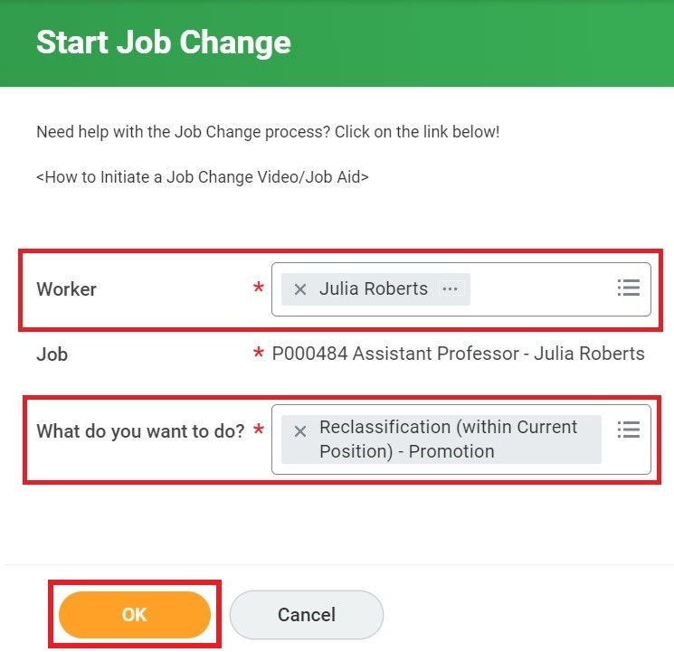

1. Click **OK** to proceed.
2. The **Start** screen appears. Click the **Edit** icon to add the start details.

1. Enter the start date in the **When do you want this change to take effect?** field. Click the **Start** button.

1. From the **Summary** screen, click the **Edit** icon to access and edit **Job** or **Location** details. Validate that the information is correct in all the fields and click the **Submit** button to confirm.

1. A pop-up window appears with a message, “**You have submitted”**. Click the **Close** icon to close the message.

**Result:**

You have completed the steps to promote a team member on Workday.