

**Purpose:** This job aid shows managers how to create/manage student job requisitions in Workday.

**Steps to create a job requisition:**

1. In the Workday **Search** bar, enter **create job** **requisition**.

1. Click on the **Create Job Requisition** task.

1. Use the Menu iconto select the **Supervisory Organization**
   1. Tip: For Student jobs, please ensure you are creating them under the “JM” organization, and not your “PM” organization. Student employees leverage Job Management instead of Position Management.
   2. Select the **Worker Type** from the drop-down list (Students should be Employee). Click **OK**.

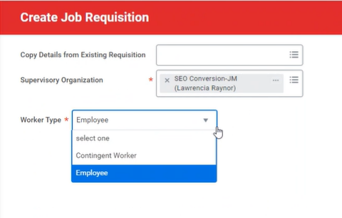

1. On the **Recruiting Information** page, enter information in all the following mandatory fields in the **Recruiting Details** section. Click the **Pencil** icon to edit the fields.
   1. **Number of Openings:** If you are planning on hiring more than 1 student into the same job, update this field to indicate that. The job requisition will stay open until you hire this number of students.
   2. **Reason**: Using the **Menu** icon, select the most suitable option from the options listed.
   3. **Replacement for**: If this position is a replacement, Populate Replacement for who is leaving the position. Please note that this step is optional and for reporting purposes only.
   4. **Recruiting Instruction**: You should indicate where the requisition should be posted – Internally and/or Externally, Hidden Posting or Do Not Post.
      1. **Note**: all student jobs should be posted internally only.
   5. **Recruiting Start Date**: This defaults from the **Create/Edit Position Restrictions** business process. This date drives **when the requisition can be posted**.
   6. **Target Hire Date**: This future dating will prevent the hire of an individual to start before the listed date. Using today’s date is acceptable. You can use the **Calendar** icon to enter **Target Hire Date** and **Target End Date**.
      1. Note: **Target End Date** is mandatory for student employees; however, you can work with the SEGAF Office to update this as needed.

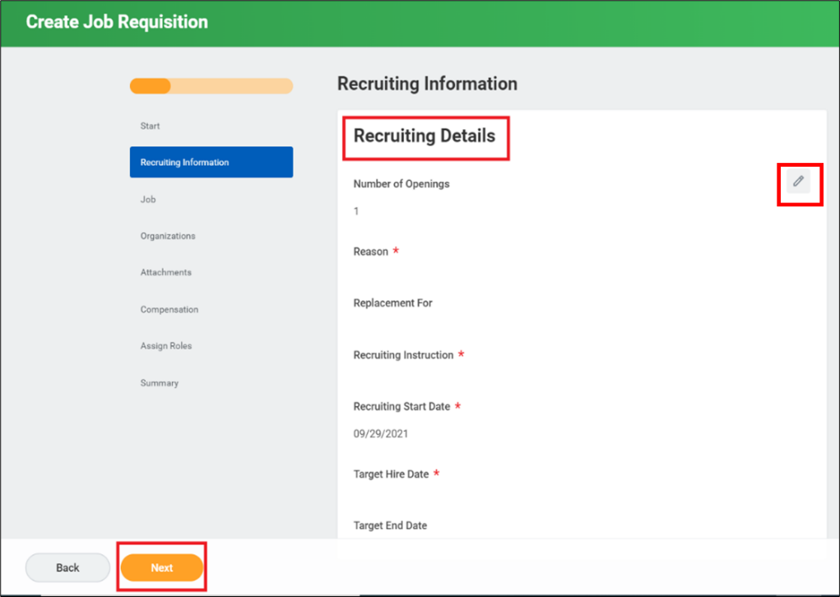

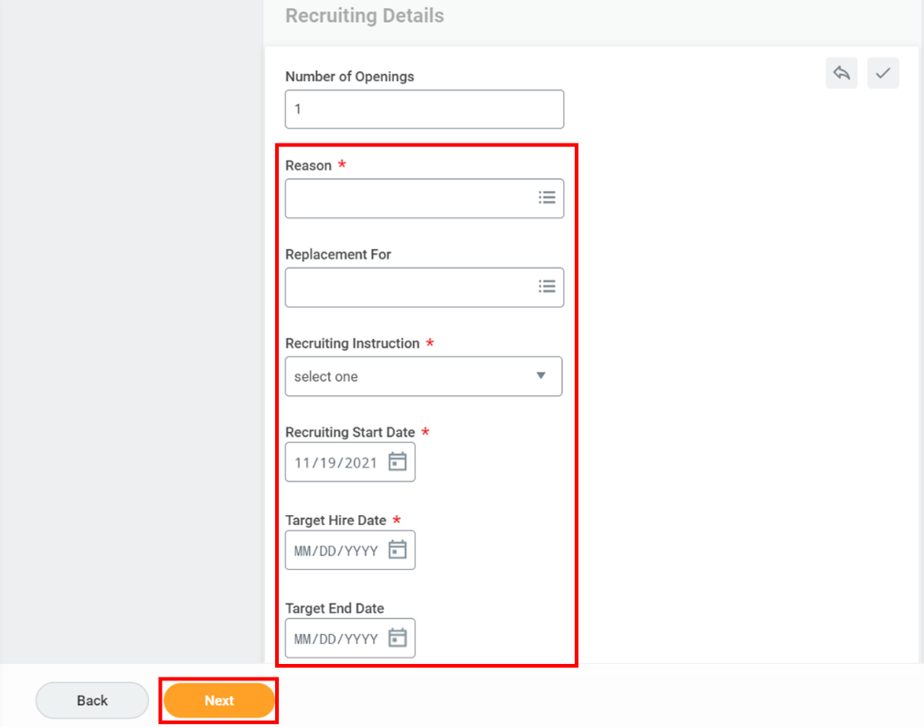

1. Click **Next** to advance to the **Job** section.
2. On the **Job** page, complete and review the **Job Details** information. The information in the Job section defaults from the **Create/Edit position** business process. Review

each section and confirm accuracy and edit using the **Menu** icon.

* 1. Under the **Job Posting Title**, enter the title, if not already defaulted.
  2. **Justification**: Explanation supporting the position, such as clerical support for the front desk, PT Faculty, and so on.
  3. Enter the **Job Profile** using **Menu** icon. The job profile can also be found by viewing the position. If filling a vacancy, the job profile does not default and will need to be selected using the **Menu** icon.
  4. If not already defaulted, enter the **Job Description** and **Additional Job Description.**
  5. **Worker Sub-type:** Click the **Menu** icon and select the appropriate type.
  6. Select the appropriate **Time Type –** Full Time or Part Time. Ensure that the **Time Type** and **Scheduled Weekly Hours** align correctly.
     1. For student requisitions the following fields should be populated as noted*:
        1. **Time type**: Part Time
        2. **Scheduled Weekly Hours**: 20 hours
        3. **Default Weekly Hours:** 40 hours

*Co-op jobs can be adjusted for full-time here

* 1. **Primary Location**: Select the location that will be the primary worksite for this position. The Location will typically be the Main Campus unless the employee is assigned to one of the other campuses.
  2. **Primary Job Posting Location**: Auto Populates based on Primary Location.
  3. Link to Evergreen Requisition will be done by HR once the requisition has been submitted.

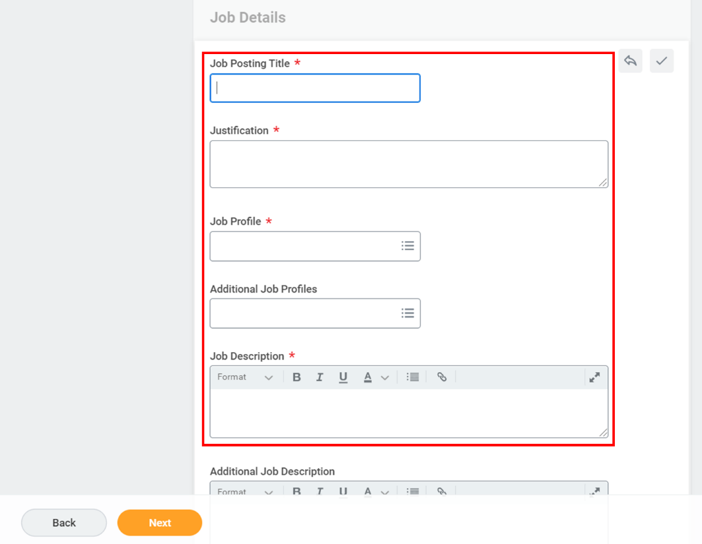

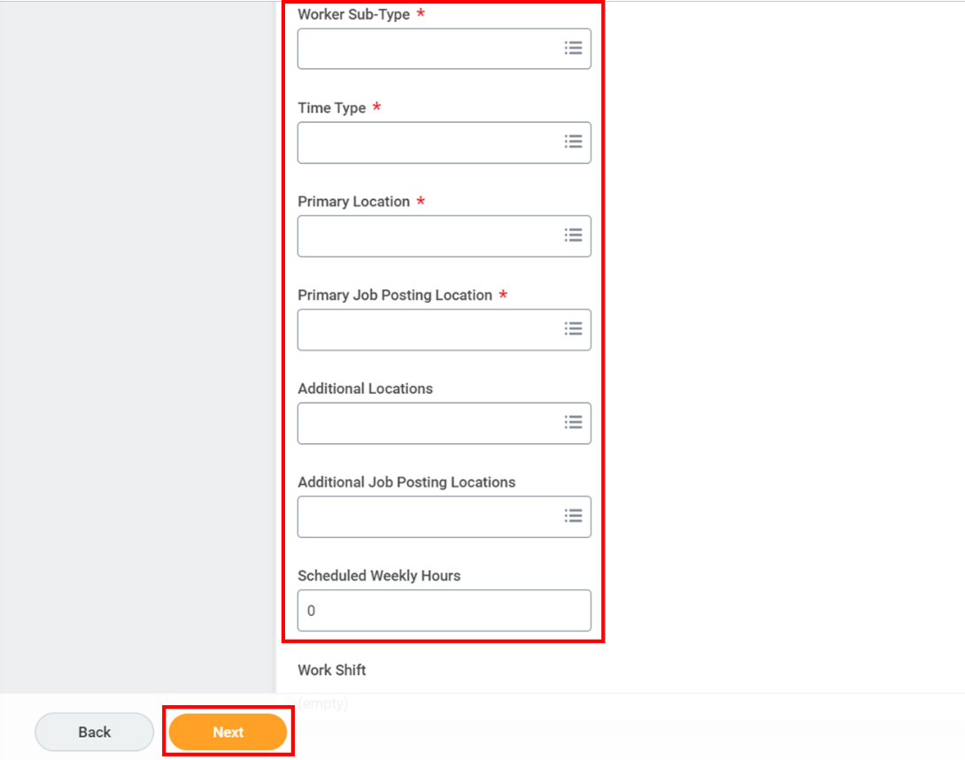

1. Click **Next**.
2. On the **Organization** page, complete and review the organization related details. Then click **Next**.

1. On the **Attachments** page, add the required supporting documents and click **Next**.

1. On the **Compensation** page, complete and review the compensation details and click **Next**. **Note**: Managers should leverage the Pay Range Descriptions when completing the compensation details section.
   1. Note: Student employees require an **hourly rate of pay**.

1. On the **Assign Role** page, add the **Role** and **Assigned To** details. In the **Assigned To** field, enter the **Primary Recruiter**’s name.

**Note:** For student requisitions, the **Primary Recruiter** role should be assigned to who will manage the approval process as part of student hiring. This should be assigned to **Lawrencia Raynor, Clare Mansfield, April Hoyt, Bec Smith, and Amanda Lipacis.**

Multiple primary recruiters can also be added. The user initiating the job requisition can also be the Primary Recruiter.

1. Click **Next**.

1. Review all the entries and click **Submit**. Graphical user interface, application

   Description automatically generated
2. Fill out the questionnaire following the requisition creation to indicate the job category.

**Result:**

You have created a job requisition request in Workday. From here, all student job requisitions will be reviewed by SEGAF to ensure all details are accurate.