

**Purpose:** This job aid provides step-by-step instructions for managers to delegate Workday Inbox tasks to another employee to perform tasks on their behalf during their period of absence.

**Add Inbox Delegations:**

1. Click the **Tray** icon on the top right corner of your Workday Homepage to navigate to your Inbox.

1. Navigate to your Workday inbox and click the **Actions** tab.

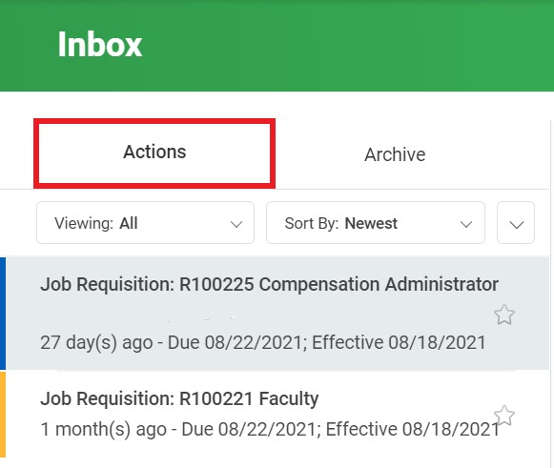

1. Click the **Down** arrow icon to view the drop-down menu with **My Delegations** option.

1. Click the **Manage Delegations** button.

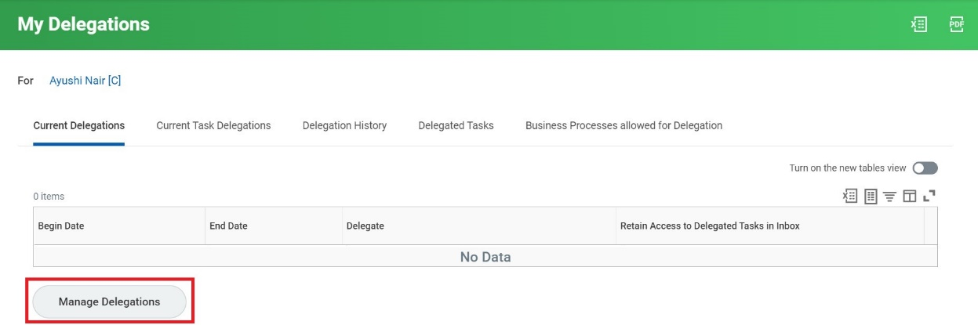

1. Enter the relevant dates in the **Begin** **Date** and **End Date** fields to set the duration for delegation.
2. Search and select the person you want to delegate your inbox to in the **Delegate** field.

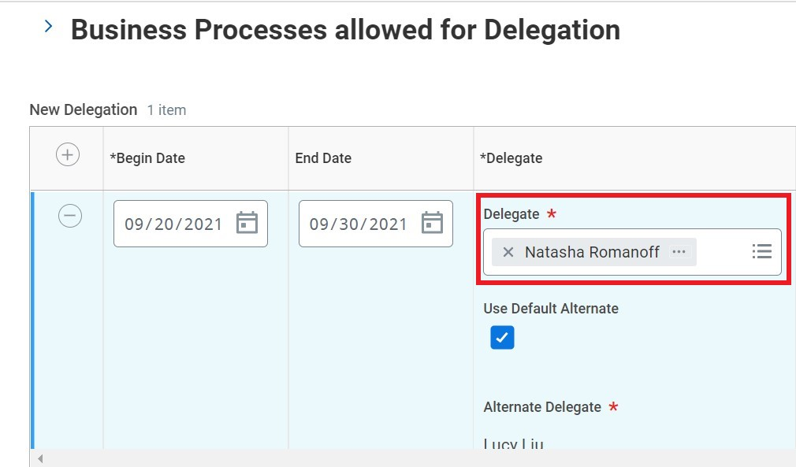

1. In the **Do Inbox Tasks on My Behalf** section, select the type of tasks that you want to delegate from the list of options:
   1. All business processes
   2. Specific business processes

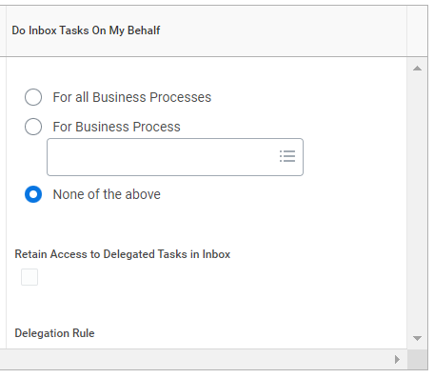

Please note that for delegating time sheet approvals, select the **For Business Processes** radio button and enter **Request Time Off** and **Enter Time** business process in the field. This will allow your delegate(s) to view and act on approving time for both salaried and hourly employees.

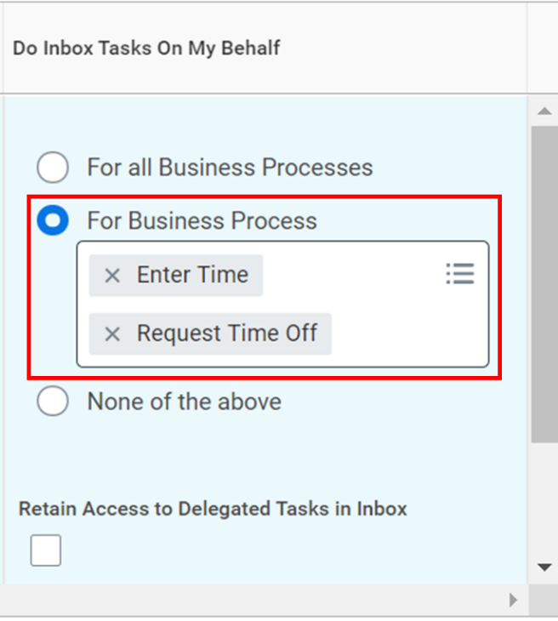

1. Select the **Retain Access to Delegated Tasks in Inbox** checkbox to view and modify your Inbox while delegating.

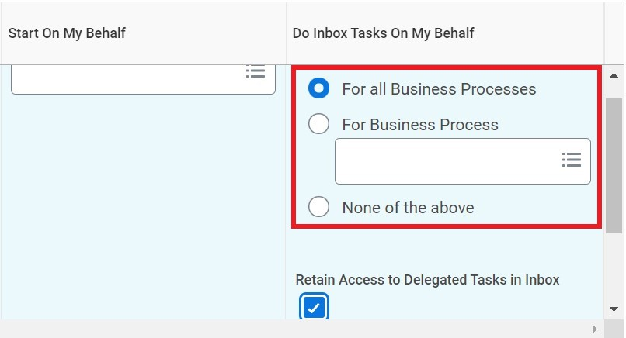

1. If you want to restrict the delegation for a specific business process, search and select the relevant business process in the **Delegation Rule** field.

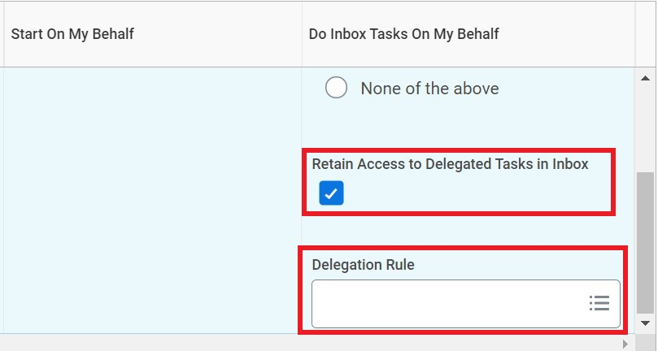

1. Click **Submit**.

1. A confirmation message is displayed on screen. The request is then routed to Manager for approval.

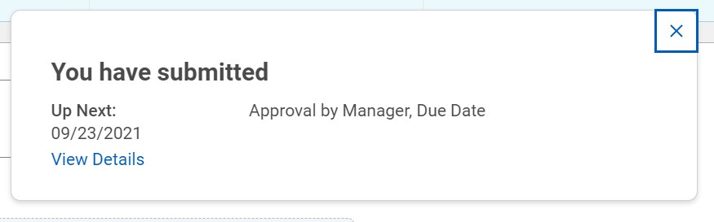

**Result:**

You have completed the steps to delegate your Workday inbox tasks.