

**Purpose:** Student Employees will enter their time through Workday Time Tracking.This job aid describes the steps to submit your time on a web browser and on the Workday mobile app.

**Steps to submit time on web browser:**

1. Log in to Workday.
2. Go to **View All Apps**
3. Navigate toyour **Time application**.

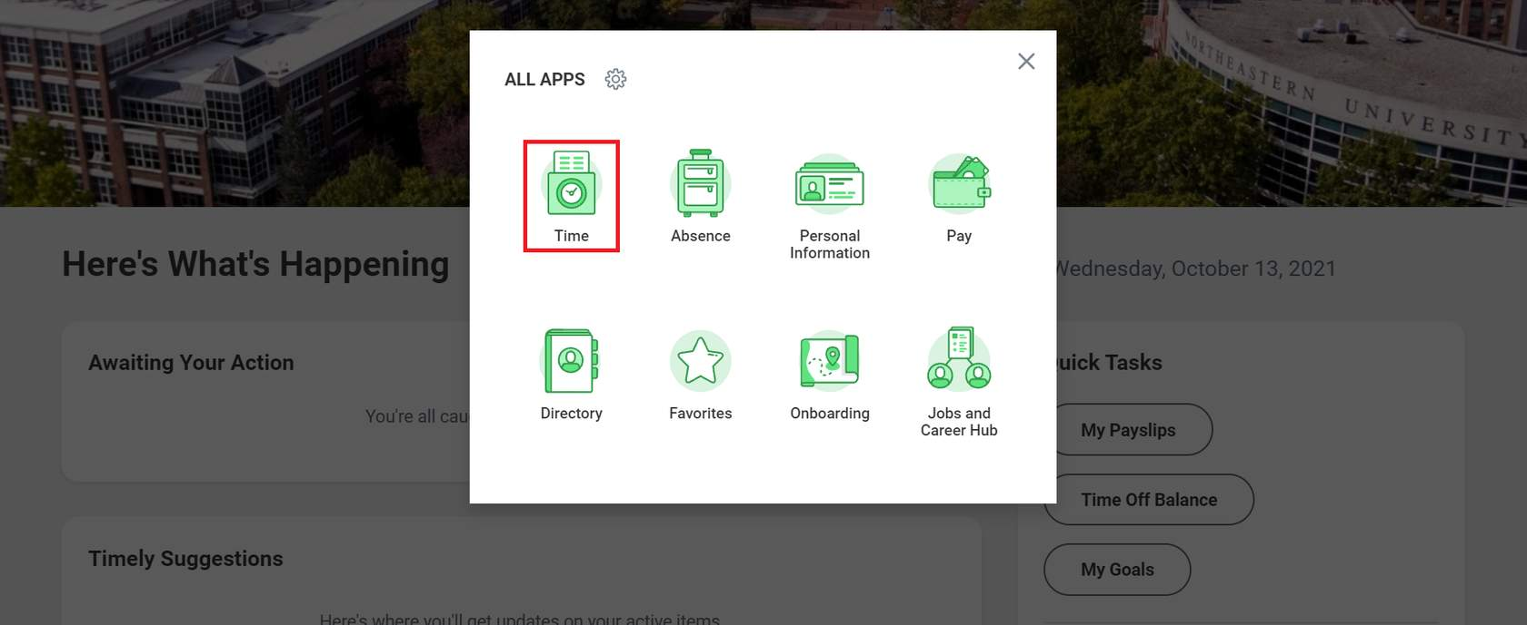

1. Under the **Enter Time** column, select This Week, Last Week or Select Week based on the week you want to enter time for.

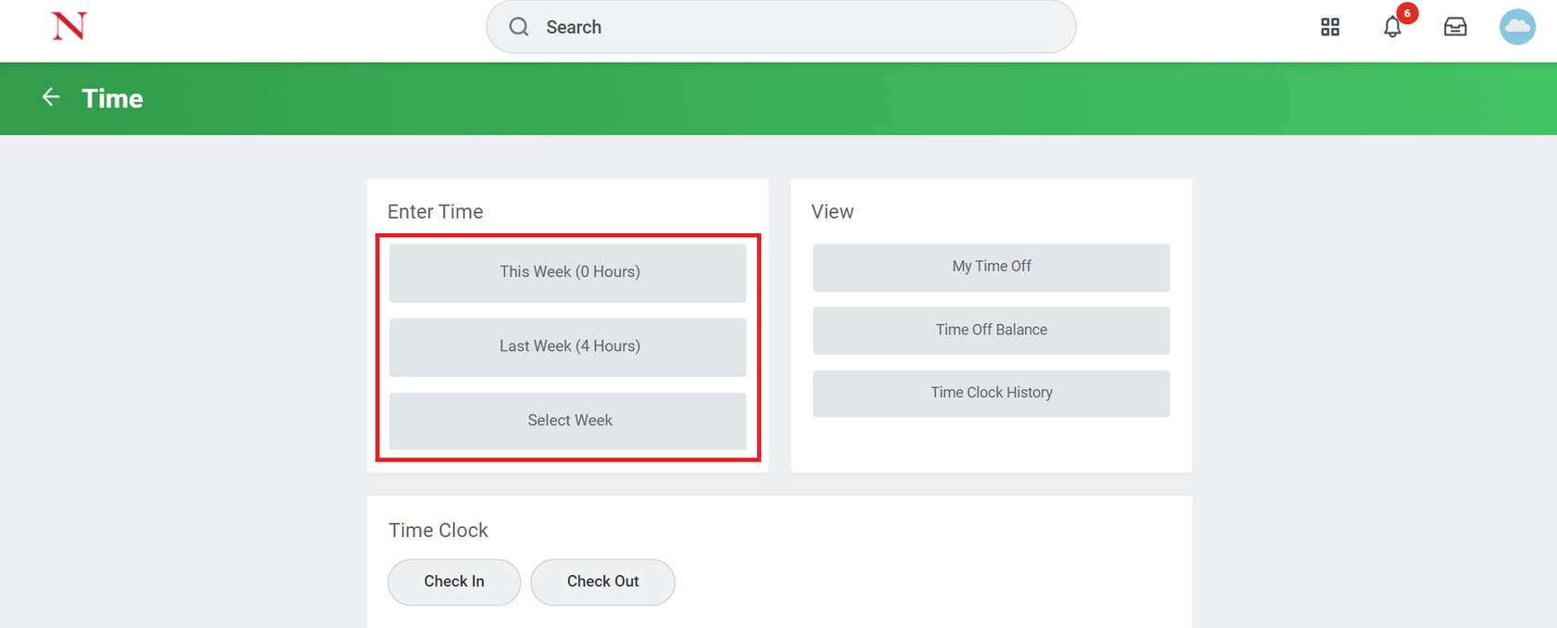

1. Select the **date on the calendar** that you would like to input time for.

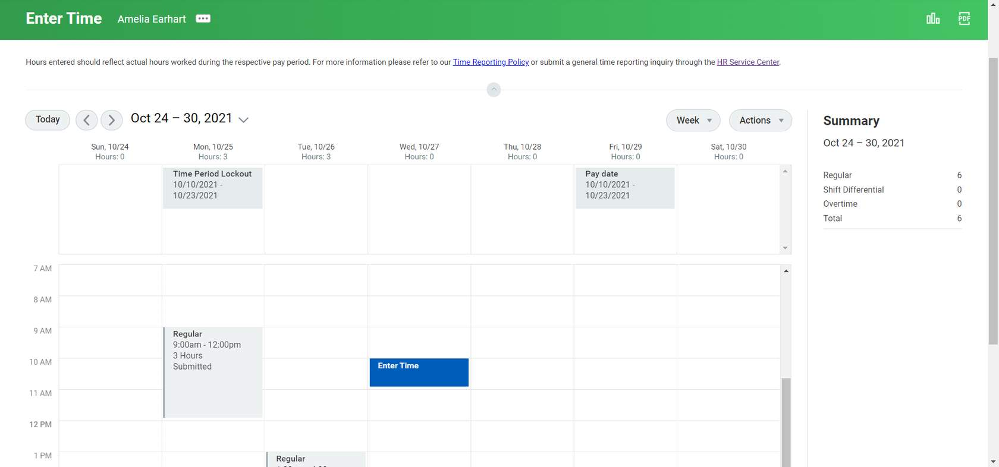

1. In the **Enter Time** pop up screen enter your in and out time for the day, along with any additional comments. Once complete, Click 'OK.'

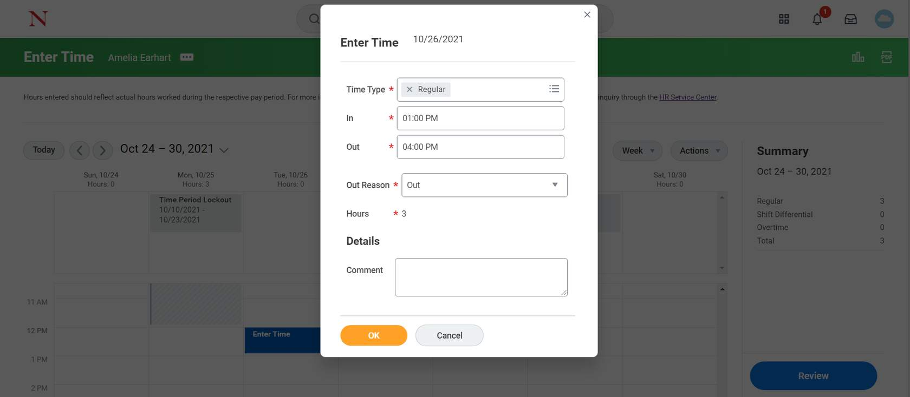

1. After you have accurately entered your time in your timesheet, you should select the 'Review' button on the right hand side of the calendar.

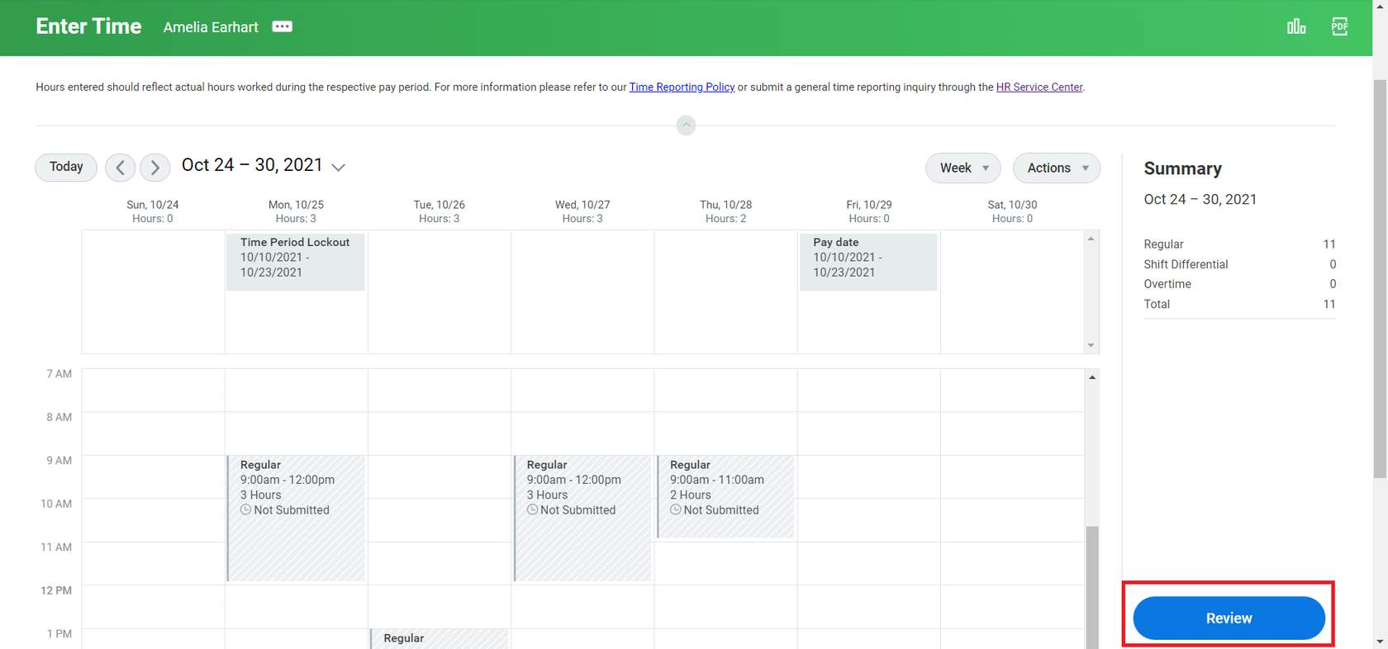

1. After clicking the 'Review' button, you will be prompted with another box that provides a summary of your hours for the selected time period. Once you have reviewed and confirmed this information is correct, select the 'Submit' button.

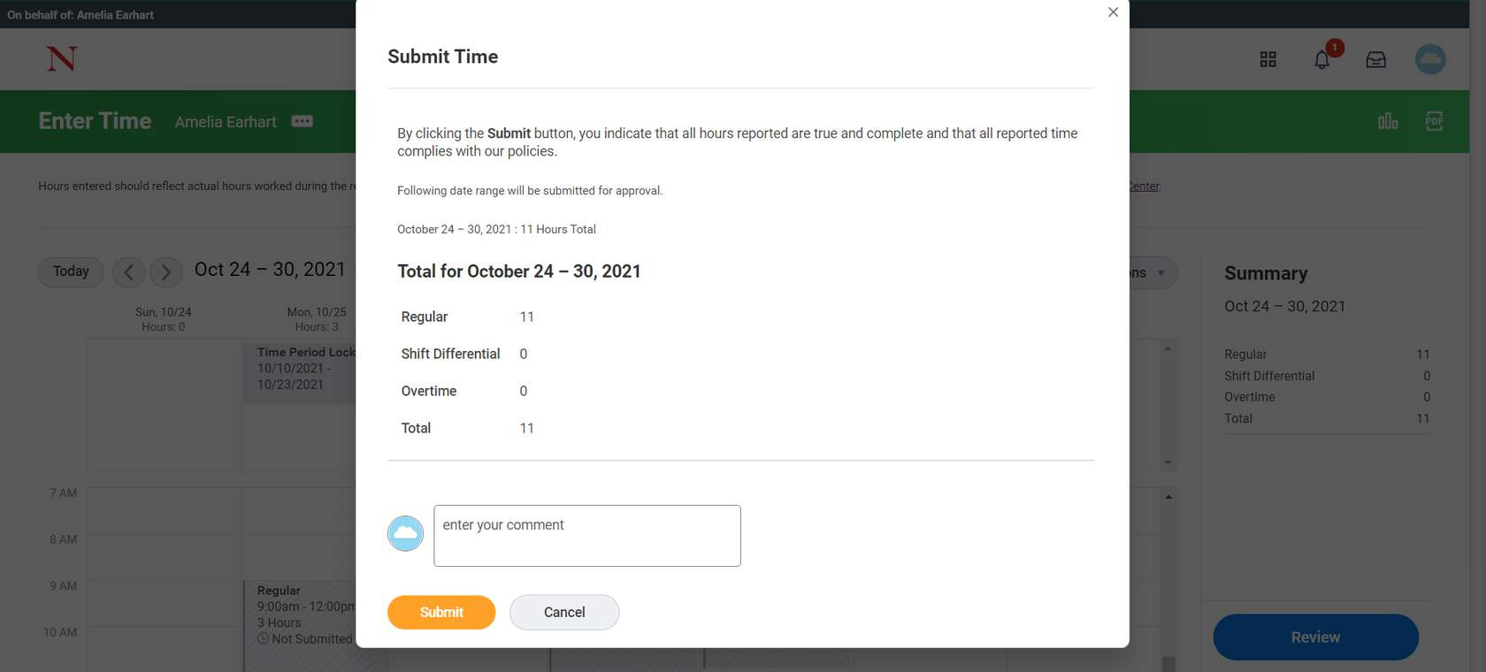

**Steps to submit time on Workday Mobile App:**

1. Log in to Workday app.
2. Navigate toyour **Time Tracking** application.

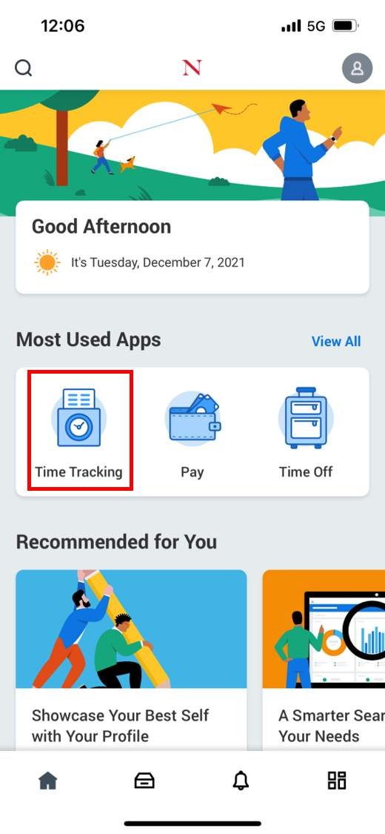

1. Select **Enter Time from** the list provided to input hours worked.



1. From the calendar view, select the **date** you would like to enter time for and then select **Add New**.

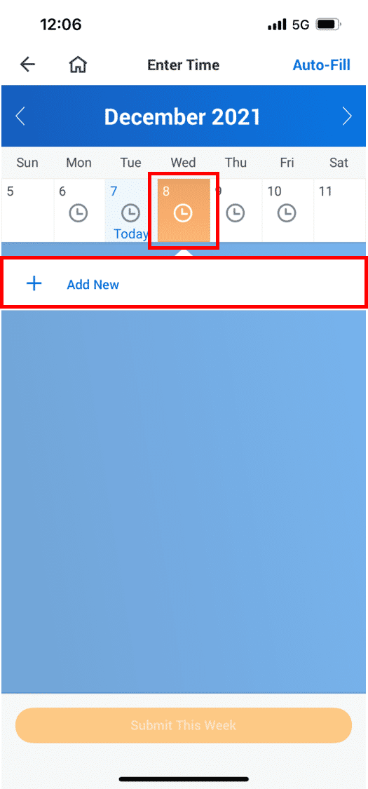

1. On the next screen, indicate the **Time Type** and the respective number of hours worked. Once you have completed these fields click **OK**.

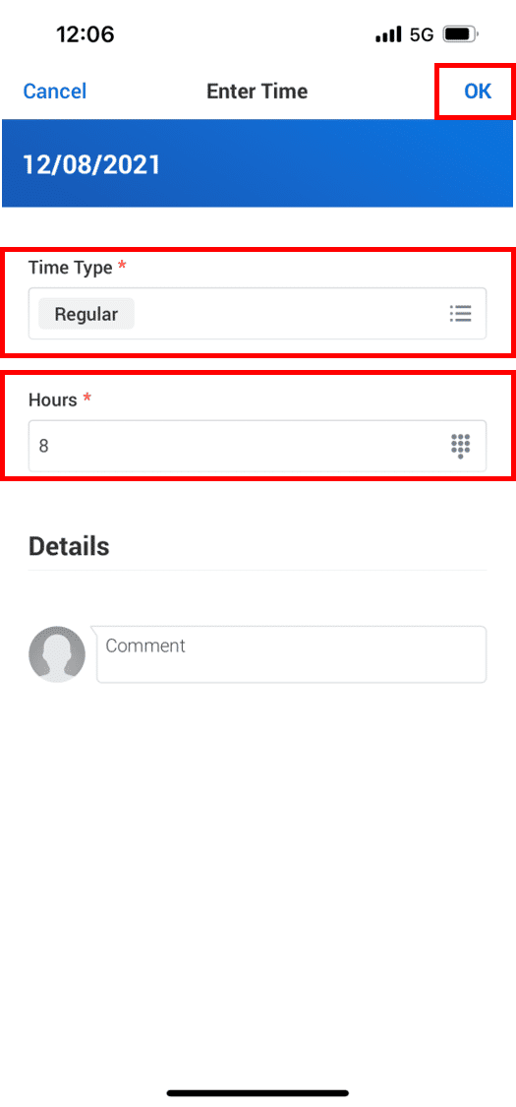

1. Once you click **OK** you will now see the hours listed in your calendar for the corresponding date.

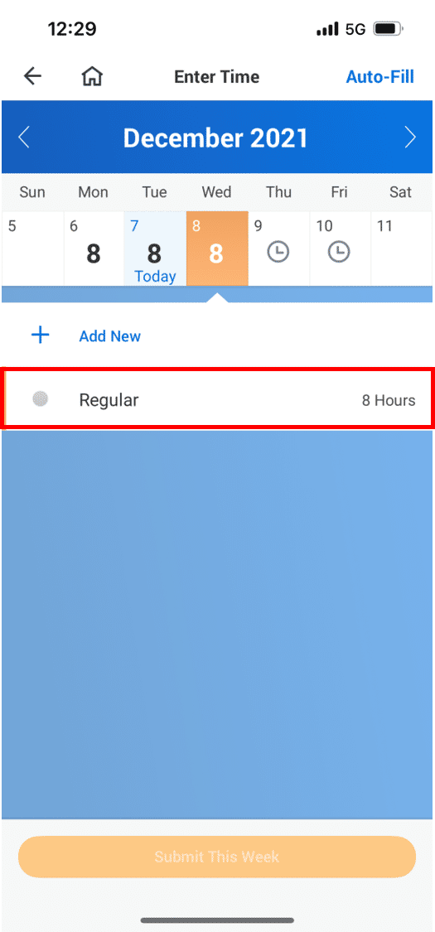

1. After you have recorded all your hours for the week, you should click **Submit** to review your hours summary, then click **Submit** again for manager approval.

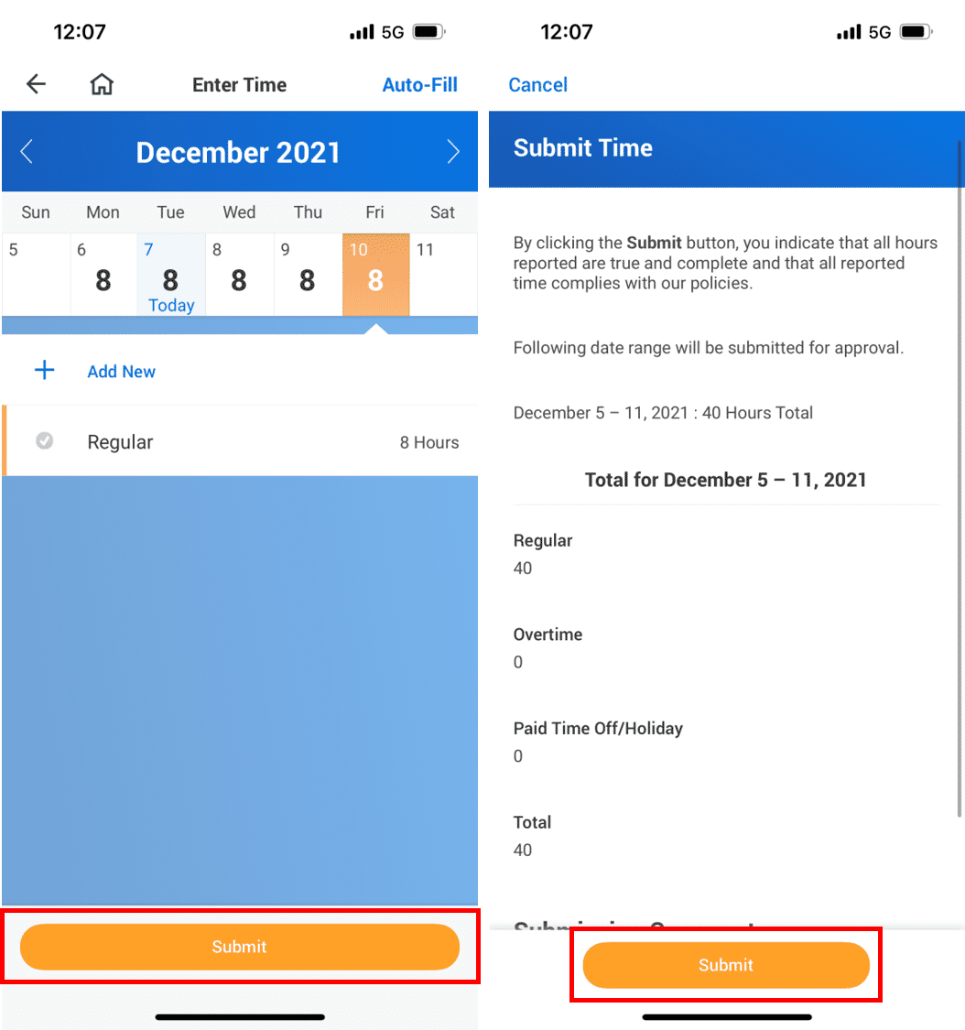

**Result:** You have submitted your timesheet for review in Workday. From here, your manager will be prompted to review your timesheet and approve if accurate.