Purpose: Student employees can complete Section 1 of the Form I-9.
Steps to complete Section 1 of the Form I-9 in Workday:
- Log in to Workday at https://www.myworkday.com/northeastern
- Go to View All Apps
- Select the Jobs and Career Hub application.

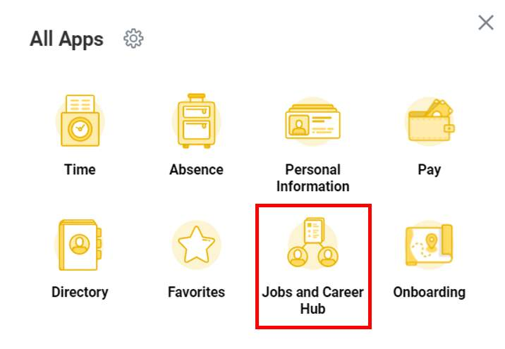

- Once you have selected the Jobs and Career Hub app, students should toggle to the Student Employment Tab to access available jobs, review open applications, and submit I-9 information (as needed).
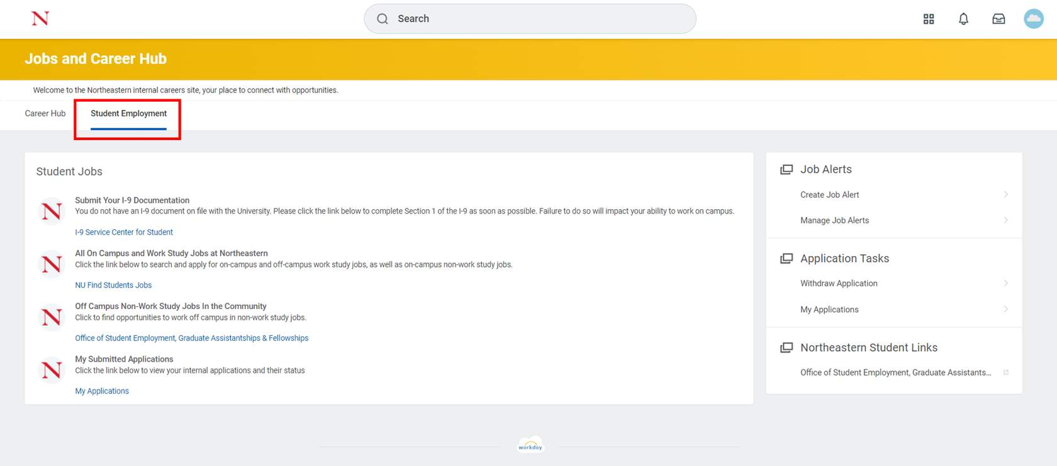

- Students can access the I-9 Service Center to complete Section 1 of the Form I-9.

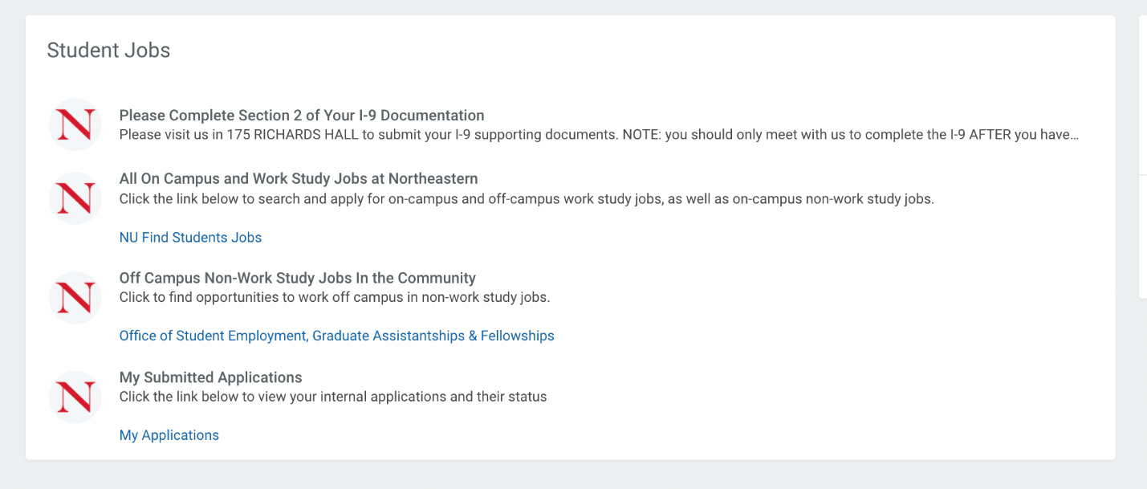

Result: You have completed Section 1.
Some key items to note:
- You must report to 175 Richards Hall to complete Section 2 of your Form I-9. You must bring original identification documentation with you. Please see the list of acceptable documents.

