

**Purpose:** Student managers will view/approve/reject the timesheet for their direct reports on a recurring basis. They are responsible for reviewing and approving timesheets in a timely manner.

**Steps to approve a student timesheet in Workday:**

1. Log in to Workday.
2. Go to **View All Apps**
3. Select the **Time and Absence** application.

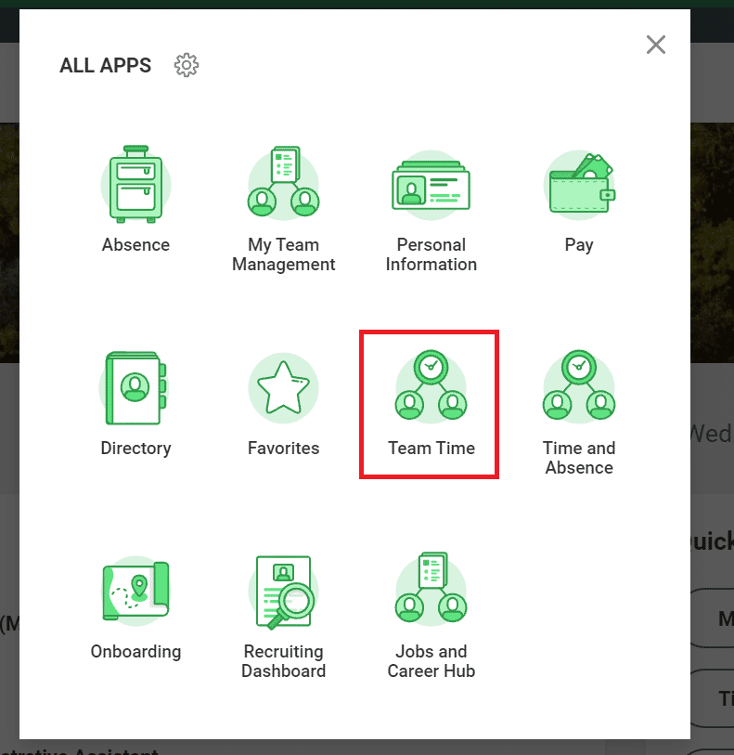

1. Once you have selected the **Time and Absence** app, Under the Actions Column, Select **Review Time**.

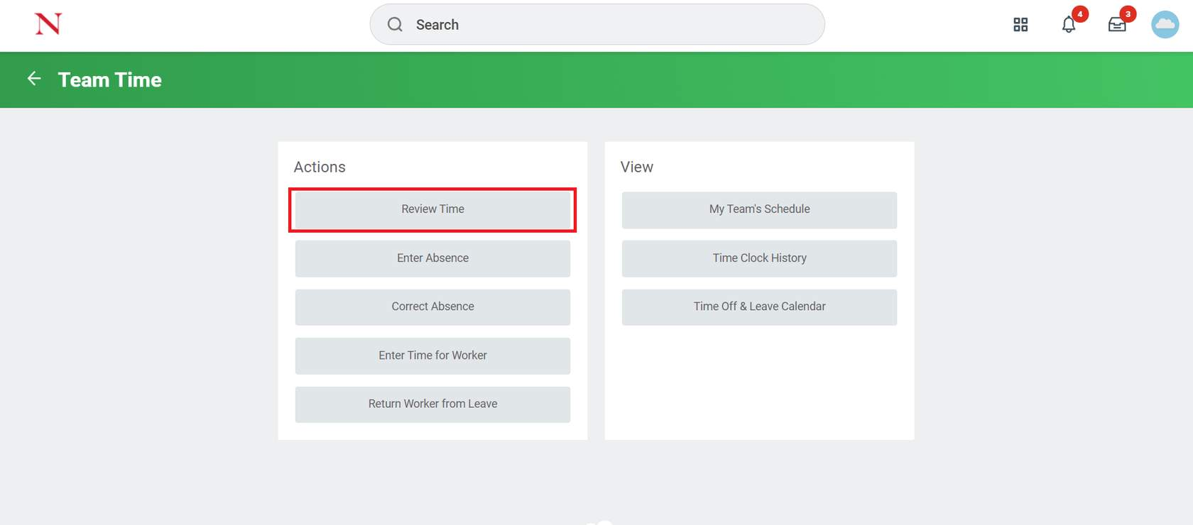

1. In the **Review Time** pop-up page, enter the Worker details of the employees to approve time.

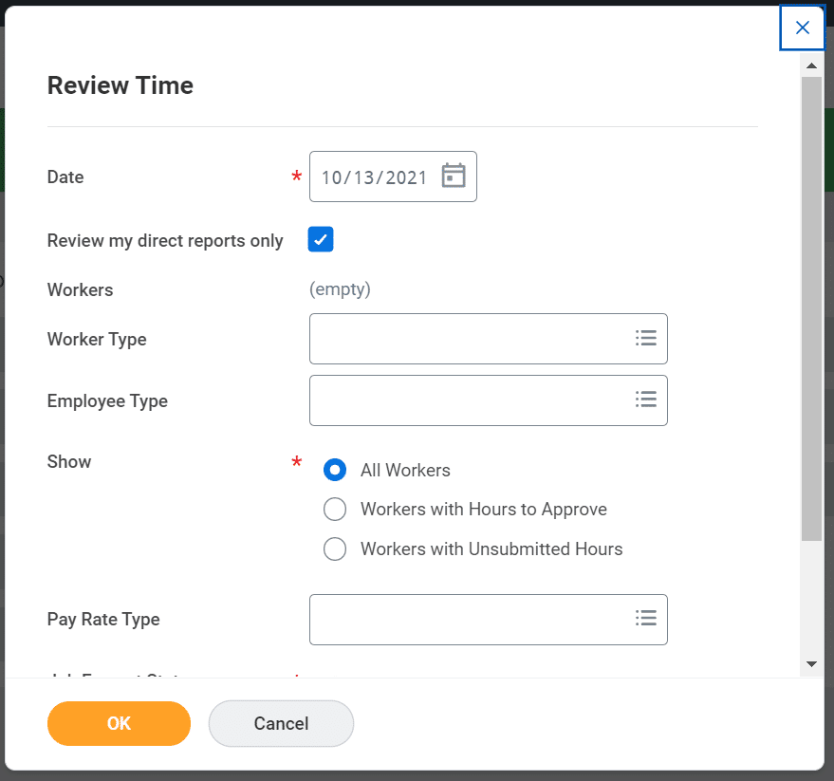

1. You will then have access to a **full list of your direct reports** and a breakdown of their hours. Pay special attention to any alerts or symbols on the **Review Time** screen prior to approving timesheets. As a reminder, student employees can only work a maximum of 20 hours per week. If one of your student employees has submitted more than 20 hours for a given week, you will see a red symbol next to their hours. Please work with the student and the SEGAF office to ensure your student employees are not working over the maximum allotted hours.
2. You can quickly approve hours for employees by checking the box next to their name then selecting the **Approve** button.

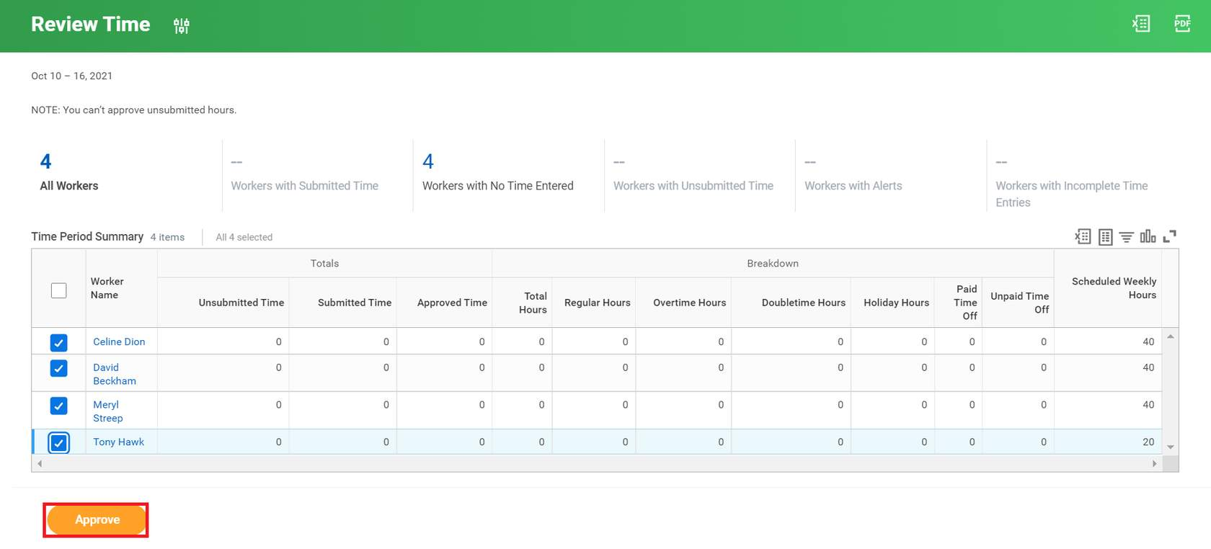

Note: If there are individuals who need more careful review, you can select their name from the list to access their timecard and make updates or send back if necessary. Any updates should include a manager’s note in the comment field.

**Result:** You have reviewed the steps to approve time for a student worker in Workday.