

**Purpose:** Student employees can apply for on-campus and work-study jobs directly in Workday through the Jobs and Careers Hub. You can find a list of all student jobs by searching for the NU Find Students Jobs report.

**Steps to apply for a student job in Workday:**

1. Log in to Workday.
2. Go to **View All Apps**
3. Select the **Jobs and Career Hub** application.

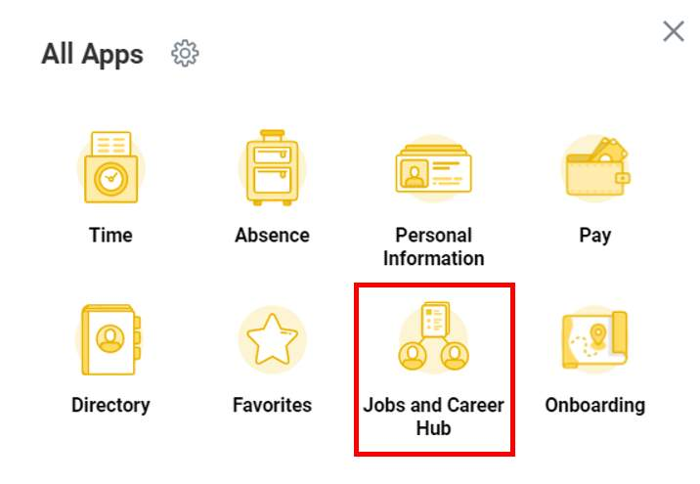

1. Once you have selected the **Jobs and Career Hub** app, students should toggle to the **Student Employment Tab** to access available jobs, review open applications, and submit I-9 information (as needed).
2. 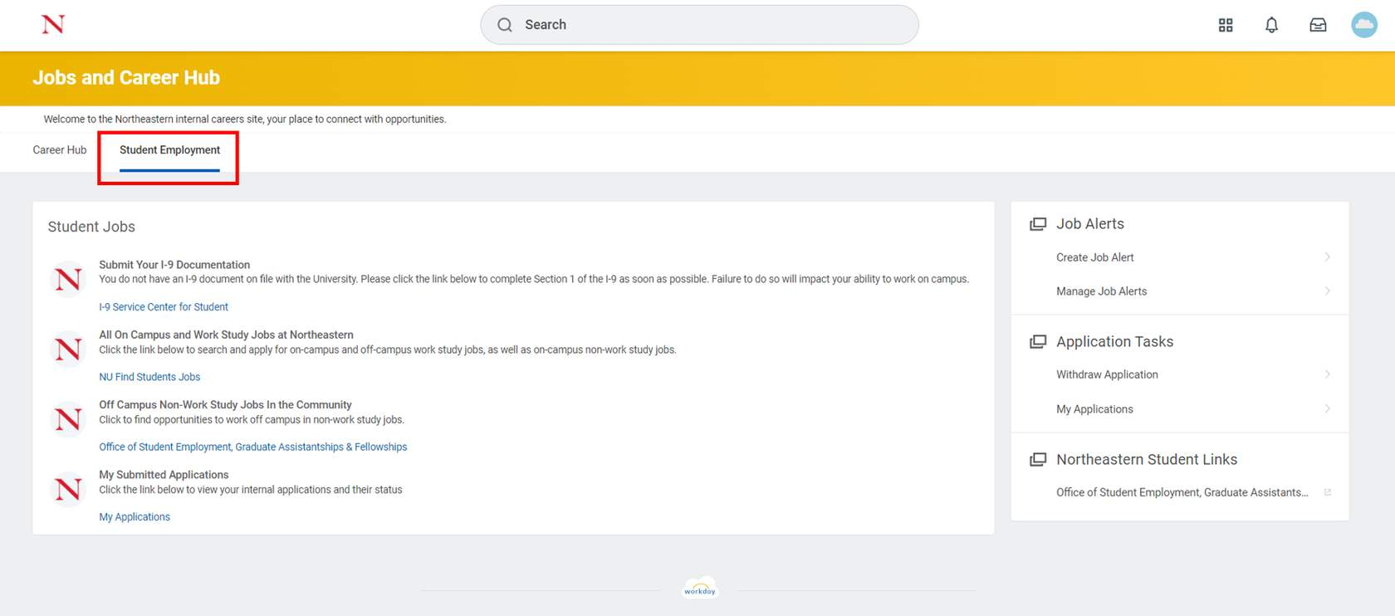
3. Students can view all on campus and work study jobs at Northeastern by accessing the **NU Find Student Jobs** report. This will include job descriptions and other general information about the role.
4. 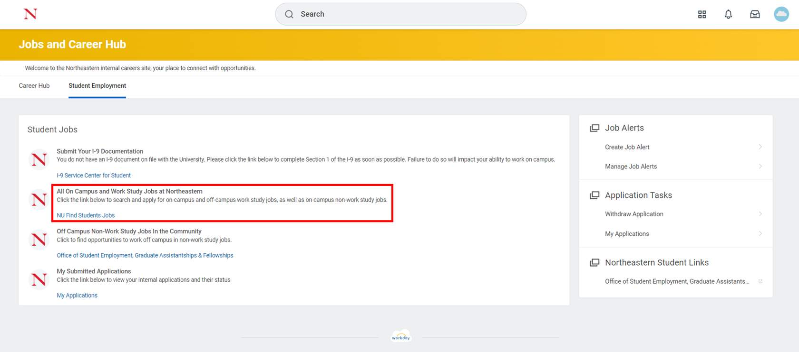
5. If you come across an opportunity that interests you, students can apply for the open role in Workday directly from the Job Posting Details page.

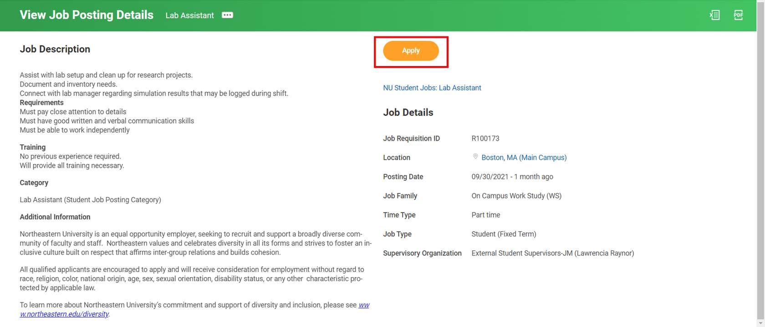

**Result:** You have reviewed the steps to apply for a student job in Workday.

**Some key items to note:**

* Students can apply for work-study jobs even if they are not awarded work study. However, they will be automatically removed from the candidate pool and receive an email notifying them of the change in status.
* Students eligible to work off campus can search for off campus non-work-study positions through the Student Employment site.