Purpose: This job aid shows managers how to hire a student in Workday.
Steps to hire a student:
- In Workday, find your Job Requisitions workspace. You can find it by going into your Recruiting Dashboard application; you may also see it on the left-hand side of your home screen. A list of your job requisitions will populate. Select the job number into which you wish to hire the student. Then, select open detailed view of the job.

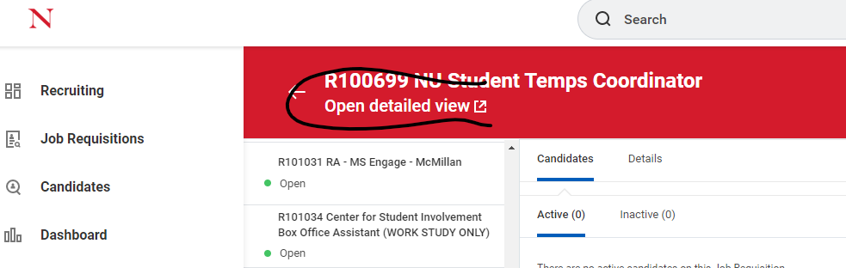

- Click on the three dots to the right of the job title.

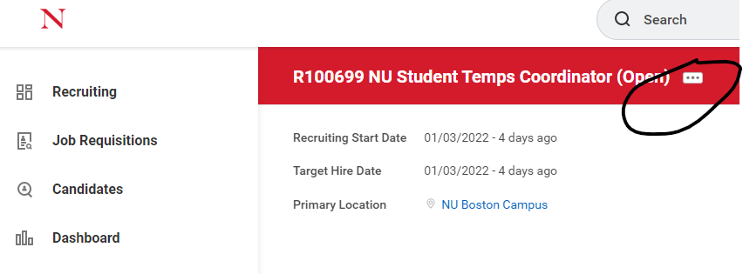

- A menu will appear. Hover over Hire and select Hire Student.
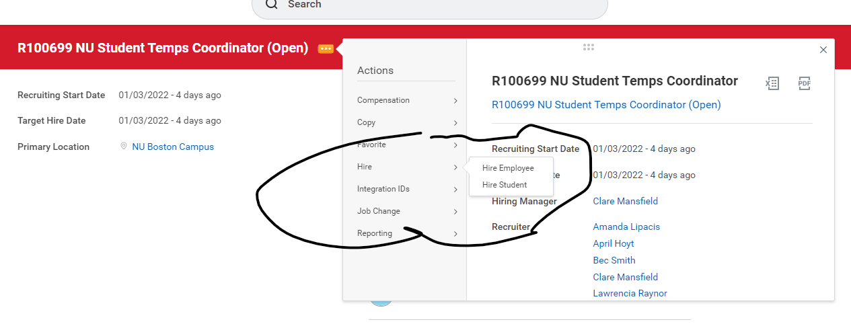

- A menu will appear. Enter the student’s first and last name and select OK.

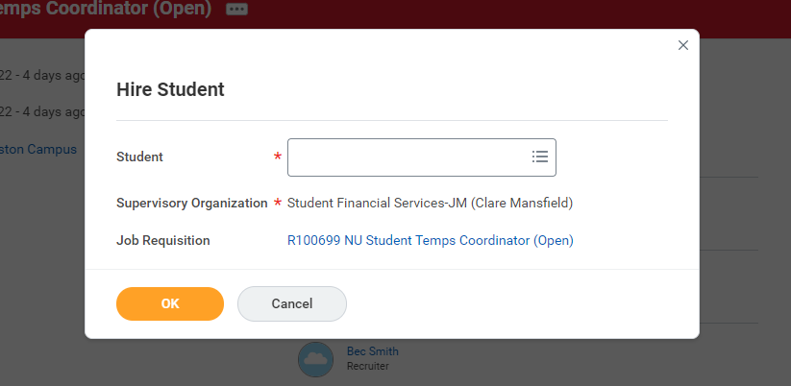

- Click Hire to begin the hire. **Please note that if the student has other jobs, you will only see an option to Add Job. Please click Add Job.
- On the Hire page, enter the hire date, then use the drop-down menu to select the hire reason (if the student was previously hired into the job in our old system, you can pick Conversion). If the job details did not pre-populate, use the Job Requisition drop down menu to find the associated job. Complete and review the Job Details information.
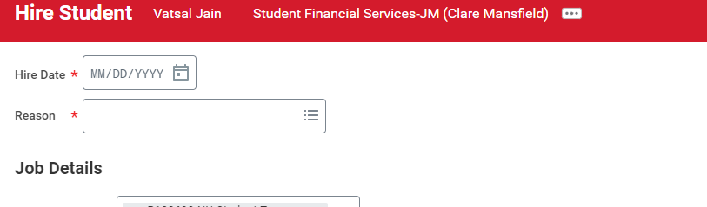

- Click the carrot next to Additional Information.
  - Update the Job Title.
  - The Business Title will match the Job Title.
  - Leave the Default Weekly Hours at 40
  - Enter the Scheduled Weekly Hours.
  - Select any relevant Additional Job Classifications or skip.
  - Select Work Shift or skip.
  - Enter the First Day of Work
  - Enter the End Employment Date.
- Click Submit.
- You’ll receive a message that you’ve successfully submitted the job and that you need to update the organizational assignment. Click Open to review/update this information. It will likely be pre-populated.
- Click the pencil icon to edit the Banner Index and Home Organization if needed. You can type these numbers in directly, or search for them by name. All other fields should be left alone. Please note that grant numbers cannot be used as the index number. If you are charging this job to a grant, enter your departments general index number in this screen; you will have the option to add a grant in the costing allocation screen.
- Click Submit. You’ll receive a message that you need to Request Compensation Change. Click Open.
- On the Compensation page, scroll down to the Hourly box. Use the pencil icon to update the hourly wage if needed. This information should pre-populate. Then click Submit.

- You’ll get a message that you’ve successfully completed this step and need to assign the costing allocation. Unless you are paying this student from grant funding*, skip this step. You do not need to enter a reason for skipping the step. Simply press OK.
- You may receive a Form I-9 alert indicating that the student needs to complete their Form I-9. If so, please advise the student to work with the Student Employment Office to complete their Form I-9. Once they have reported to our office to complete Section 2 of the Form I-9, you can return to your Workday inbox, find your To Do items, and submit this step. If you do not receive this message, this is an indication that the student has already completed their Form I-9 and is eligible to be hired. You should receive a message that the event has been submitted.

Result:
You have submitted the request to hire the student. The Student Employment Office will review the request and provide the final approvals.

*If you are paying the student using grant funding, open this step. Enter the date from which the grant should be used. Then click add and enter the grant index number. Click submit.

