

**Purpose:** This job aid describes the steps to change a business title in Workday.

**Steps to change business title:**

1. Log in to Workday.
2. In the **Search** bar, search for the **Employee**’s name.



1. From the **Worker Profile**, click on the **Actions** button to display the menu of available actions.

1. Click **Start Job Change**.

1. Enter **Title Change** in the **What do you want to do?** field. The highlighted area in the screenshot below shows you the appropriate choice to select. Click **OK** to proceed.

1. Click the **Pencil** icon to change when the change will take effect, why you are making this change and whether or not you want to use the next pay period information. The box under Do you want to use the next pay period? will be checked as a default.

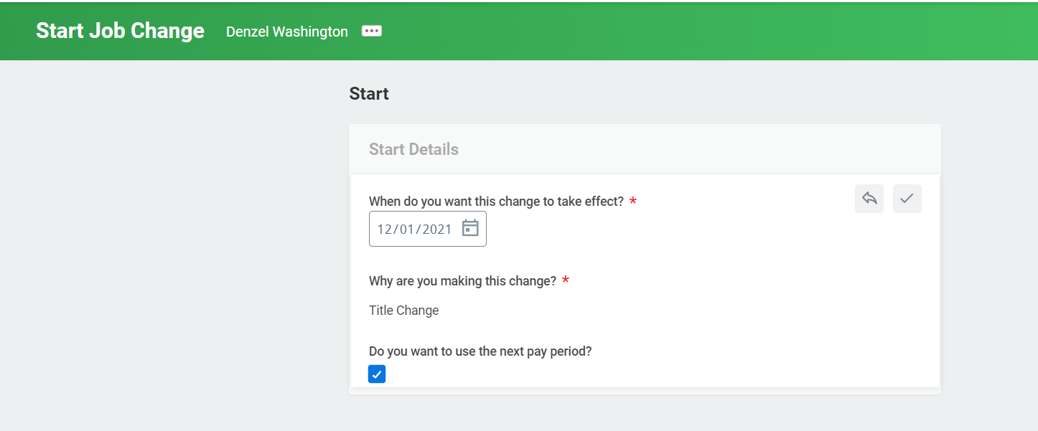

1. Click **Start** to continue the process.
2. Scroll down the screen to view the **Job** section.

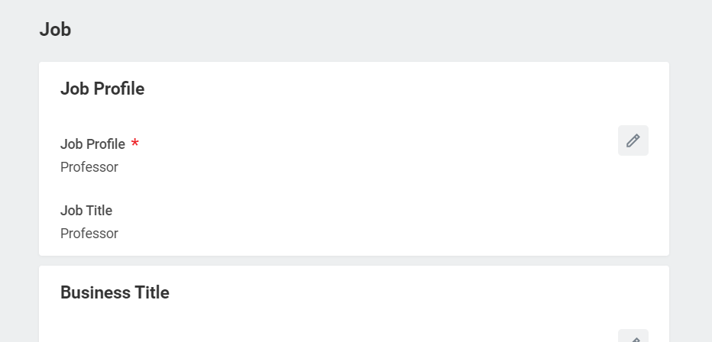

1. Click the **Pencil** icon to edit the **Business Title**.

1. Enter the proposed **Business Title.**
2. **Click** the check mark when you have finished your edits.

1. Click the **Submit** button to confirm.
2. You will receive a message indicating you have successfully submitted the task.

**Result:**

You have completed the steps to change business title in Workday.

**Additional Tips:**

If you click View Details in the box displaying that you have successfully submitted the task, you have the option to do another:

* Change Contingent Worker Details
* Change Job
* Change Location
* Request Transfer
* Start Job Change

If you click on the caret next to Details and Process, you will be able to see additional information regarding this business process.

If you click on the Details tab, you can see a summary of the Business Process you just completed.

If you click on the Process tab, you will see all the steps in the entire business process.

