

**Purpose:** When an employee is hired, they get a banner index to be charged to. If they need a costing allocation to change that, they will go through the PDC (pay distribution changes) process, where payroll can update the process.​

This job aid shows payroll partners how to assign payroll costing allocation for an employee in Workday. Costing Allocation provides the flexibility to allocate all or a portion of a salary to be paid from a Cost Center other than the default. The Costing Allocation is also where you would identify payment from a grant fund.

|  |  |  |
| --- | --- | --- |
| **Payroll Costs** | **Default Allocation** | **Are Allocations Managed by the Payroll Team?** |
| Employee earnings belonging to the **Adds to Gross** or **Adds to Net** pay component group. | Allocated to the cost centers, projects, grants, and other organization types associated with the worker’s supervisory organization. | Yes - The Cost Center Payroll Costing Specialist manages earnings through the **Assign Costing Allocation** task. |
| Employer-paid expenses  These are taxes and benefits that add to labor costs, but not to a worker’s gross or net pay. They are identified as additional pay components or in additional pay component groups for the run category. | Charged to central costing allocations. | No - Only central users can adjust the costing allocation for employer-paid expenses. |
| Other deductions and net pay | Charged to central costing allocations.  Net pay is charged to the cost center of the worker; other worktags are central accounts. | No - Only central users can adjust the costing allocation for employer-paid expenses. |

**Steps to assigning payroll costing allocation:**

1. In the Workday search bar type, **assign costing allocation**.

1. Click on the **Assign Costing Allocation** task.

1. In the **Include Existing Allocations** section, enter the **From and To date** for the cost allocation.

1. In the **Worker Costing** section, select the employees name and the **Position** will be auto populated. If the employee has any Earnings, it will be paid for by the default Organization Assignment. Click **OK**.

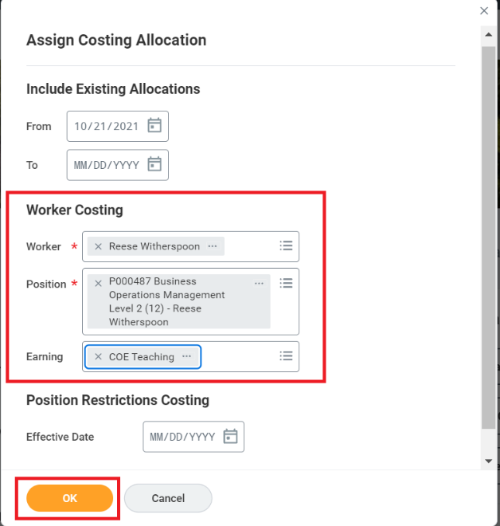

1. In the **Include Existing Allocations** section, indicate the **Start Date and End Date** of the Allocation. If the Allocation is applicable for the entire term of service for the employee, leave End Date blank. Please note that if grant funds are used, the End Date must be indicated and match the end date of the grant.

1. In the **Costing Allocation Attachments** section, enter the **Fund, Banner Index and Work Study Vendor** details. The **Distribution Percentage** is automatically updated to 100.

1. If funding will be split between multiple sources, click at the left to add another row. Enter the **Fund, Banner Index and Work Study Vendor**.

1. **Distribution Percent** should auto-calculate; overall balance should always equal 100%. If a third allocation is needed, adjust the percentage, and add another row.

1. Add any **comments** if required and click **Submit.**

**Result:**

You have completed the steps to assign a payroll costing allocation in Workday.